**Face Recognition Using Python**

**How to Run the project.**

**Step1-**Open Pycharm create new Project

**Step2-**Import OpenCv Package in Created project

**Step3-**I have uploaded 2 Python files Tester and Facerecognition

**Step4-**Tester file is the Main file to run.

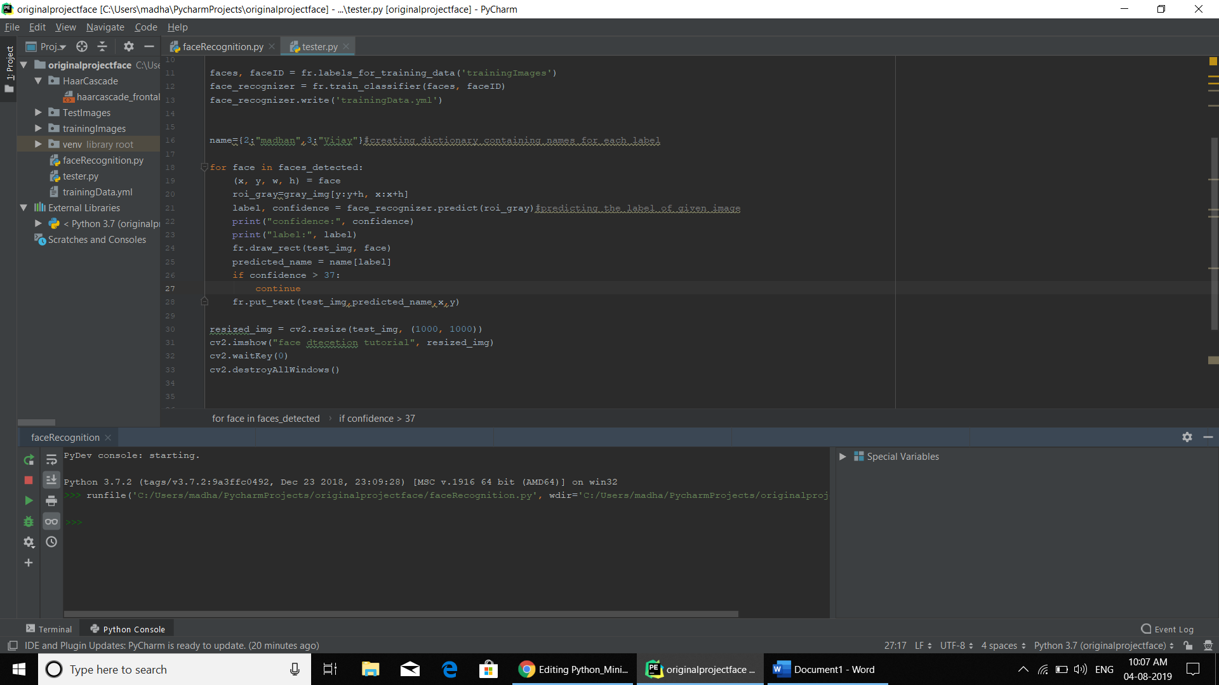

**Step5-**Before Running the Project Check the Path of the folder that you used in project is correct for example:If you want train your classifier You want to give correct path of the training images folder name

**Step6-**If You run the tester file .It will first train the classifier You can see in below screenshot in console window of pycharm

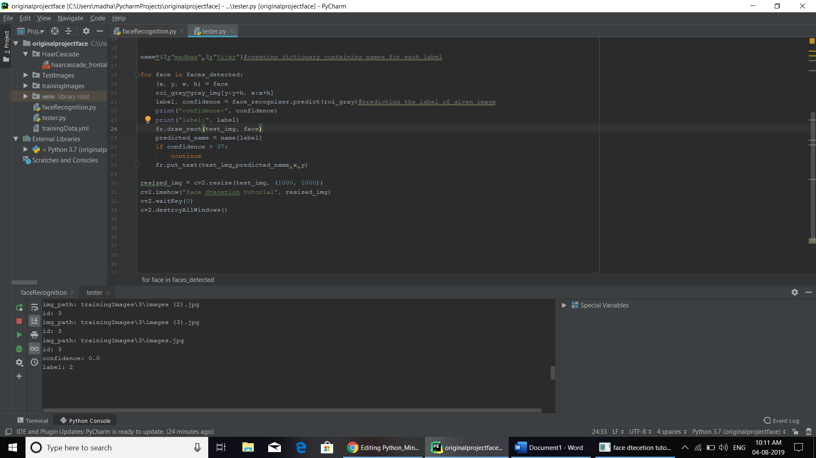

**Step7:**After Trainining of images it predict the output and give the answer in another window.You can see in below Screenshot.

